EXPERIMENT-1

ROLL NO: 240701238 NAME: Kathir Vikaas S

USER INTERFACE AND DESIGN

COMPARISON OF UI DESIGN BETWEEN TWO FIGMA CREATION

BAD WEBSITE:

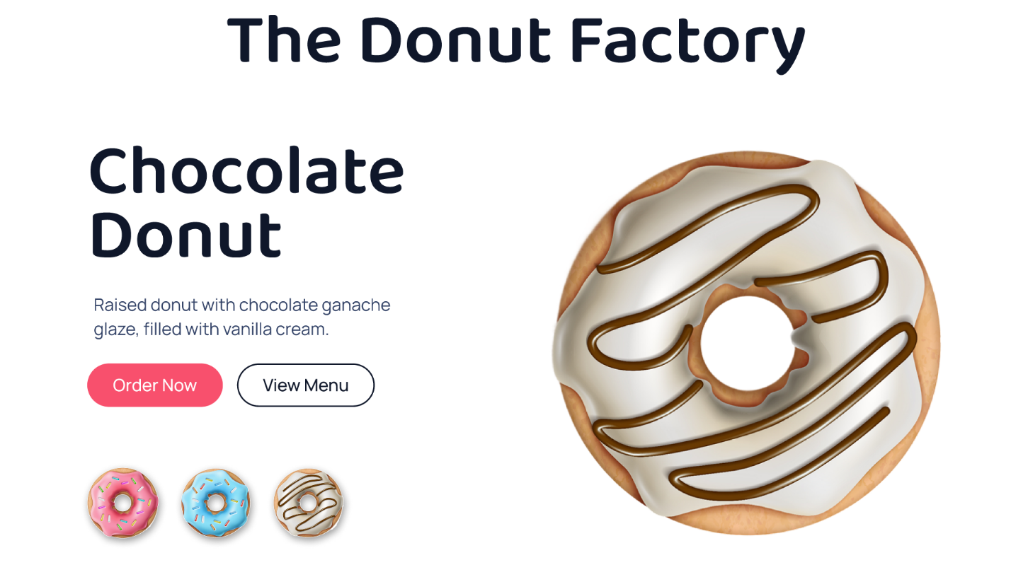

GOOD WEBSITE:

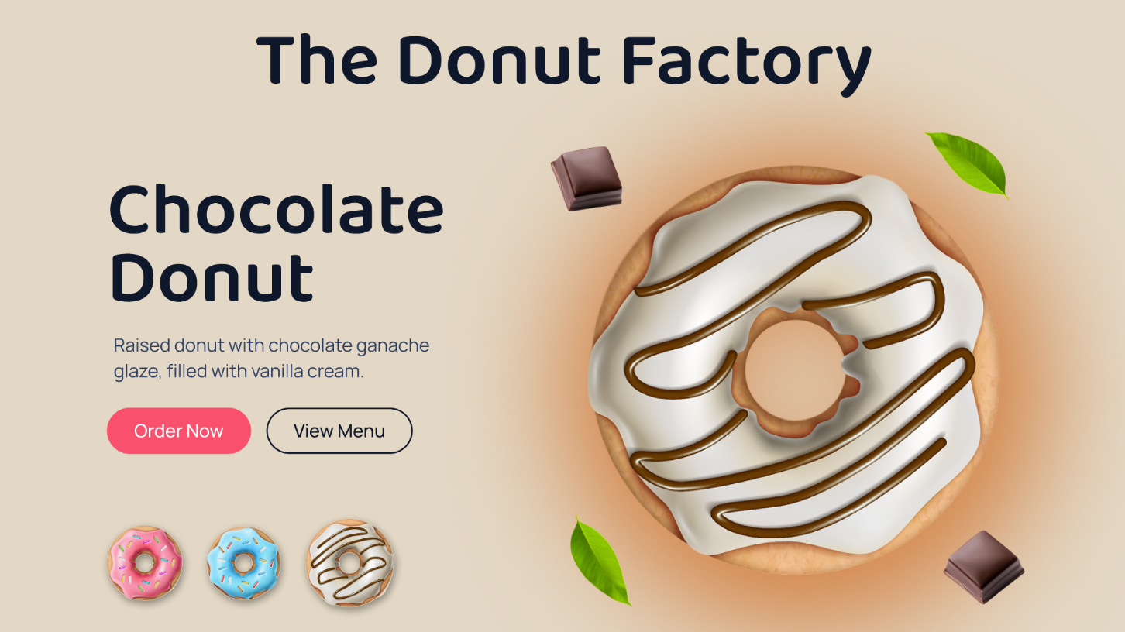
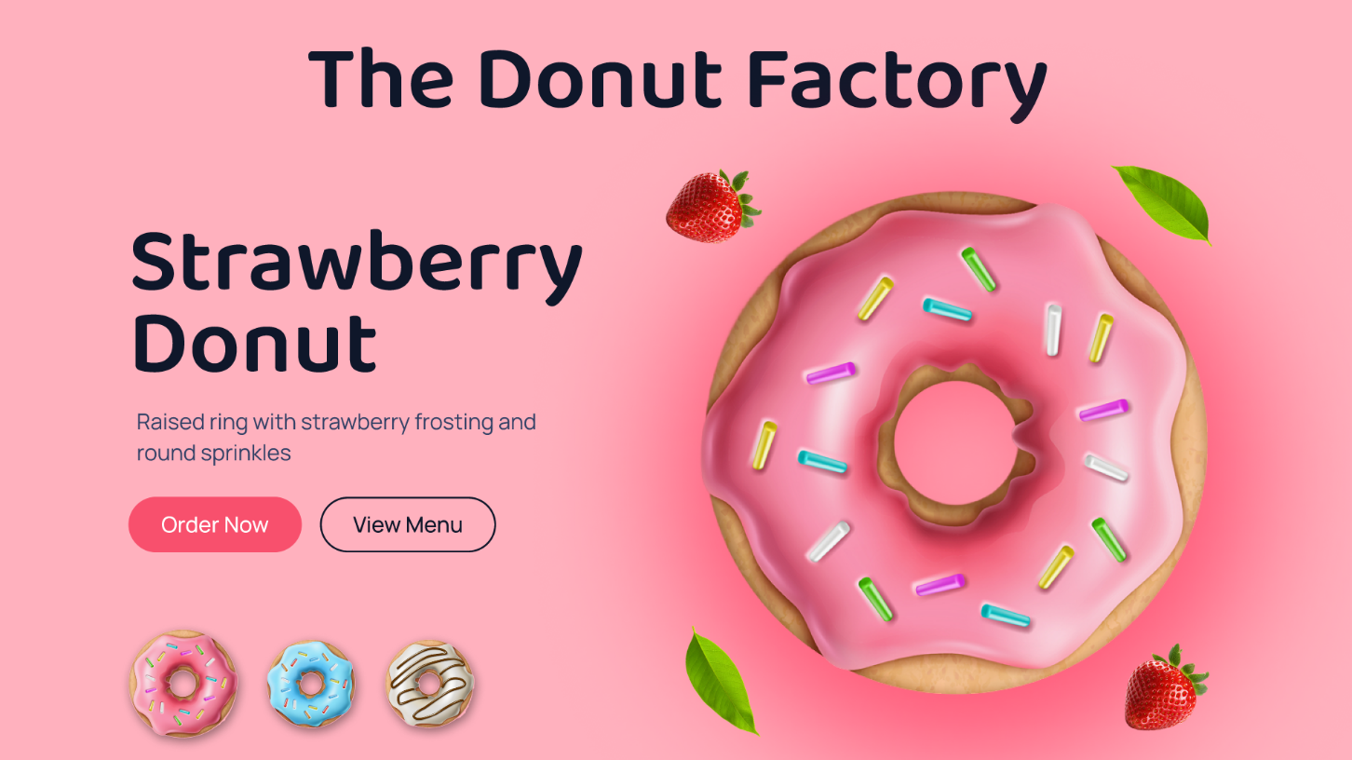
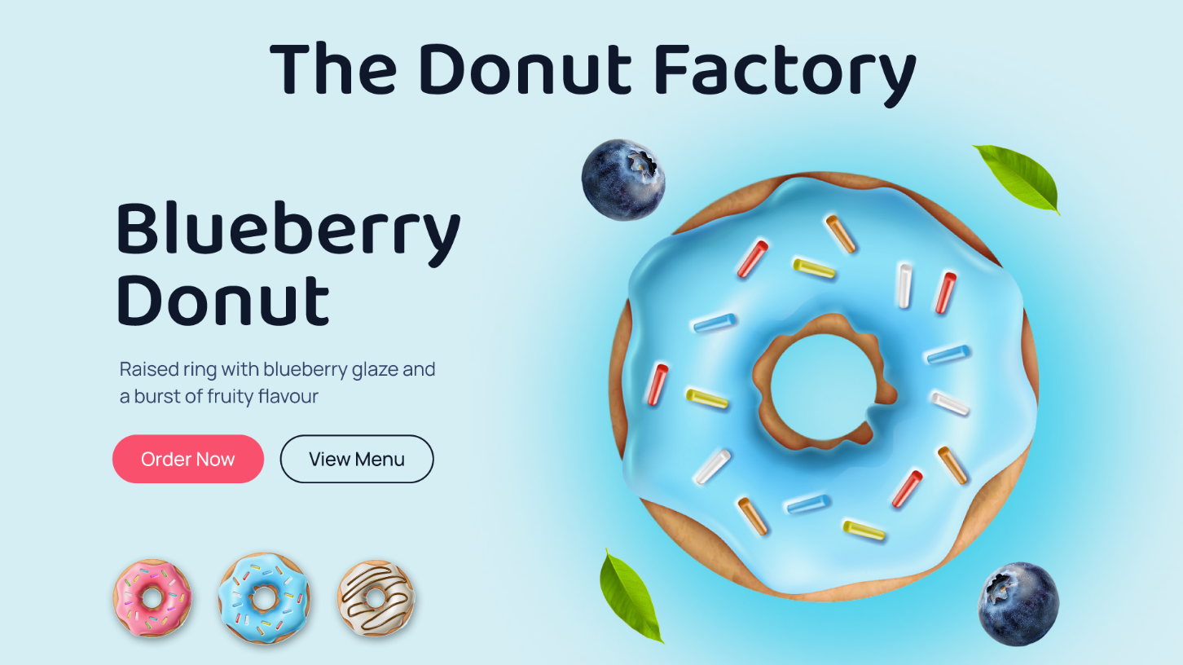

PROTOTYPE LINK:
http://figma.com/proto/TteAFgYGIjY5ncJjoQG2u4/Good-Website?node-id=6-145&p=f&t=rdXMTAFq8Z13X6rU-0&scaling=min-zoom&content-scaling=fixed&page-id=6%3A2&starting-point-node-id=6%3A102

The two websites have distinct designs and approaches. Here's a comparison:

BAD WEBSITE (Donut UI – White Background)
1. Design Style:
● Uses a plain white background with minimal visual appeal.
● Large donut image dominates the screen without balance.
● Lacks depth, shadows, or visual elements to enhance design.
● No strong color theme, making the design look dull and less engaging.

2. Content:
● Displays only one donut (Chocolate Donut).
● Includes a short and basic description.
● Content is simple but not emotionally appealing.
● Does not highlight variety or uniqueness of products.

3. Navigation:
● Includes basic buttons like “Order Now” and “View Menu.”
● No visible navigation bar (Home, About, Contact, etc.).
● Limited options for users to explore more content.

4. Purpose:
● Focuses mainly on displaying a single product.
● Suitable for basic viewing but lacks engagement.
● Does not create strong interest or interaction for users.

GOOD WEBSITE (Donut UI – Brown Background)
1. Design Style:
● Uses a warm brown background that enhances visual appeal.
● Maintains a consistent color theme related to food (chocolate tones).
● Includes decorative elements (leaves, chocolates) for better aesthetics.
● Proper spacing, alignment, and balanced layout.
● Creates a visually rich and modern interface.

2. Content:
● Highlights the Chocolate Donut with an attractive description.
● Uses engaging and descriptive text (rich, creamy, delicious).
● Displays multiple donut options as small previews.
● Content is more appealing and encourages user interest.

3. Navigation:
● Includes clear call-to-action buttons (“Order Now”, “View Menu”).
● Provides visual navigation through donut thumbnails.
● Easy for users to explore different donut varieties.

4. Purpose:
● Focuses on user experience and product attraction.
● Creates a strong visual and emotional connection with users.
● Encourages interaction and increases interest in the product.

KEY DIFFERENCES:
● Focus:
○ Bad Website → Simple display of a single donut
○ Good Website → Attractive presentation with product variety
● Design Aesthetics:
○ Bad Website → Plain and less engaging
○ Good Website → Warm, modern, and visually appealing
● Content Depth:
○ Bad Website → Basic and minimal
○ Good Website → Engaging and descriptive
● Navigation:
○ Bad Website → Limited interaction
○ Good Website → Easy and interactive exploration
● User Experience:
○ Bad Website → Basic browsing
○ Good Website → Interactive and appealing experience

